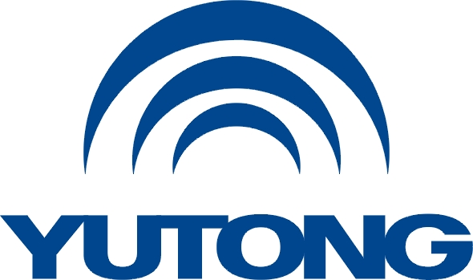

**Media Kit**

**For the Busworld Europe 2025**

**Yutong Exhibited Products**

Yutong Bus Co., Ltd.

October, 2025

**Exhibited Products**

**I. IC12E —— The Standard of Battery Electric Intercity Bus**

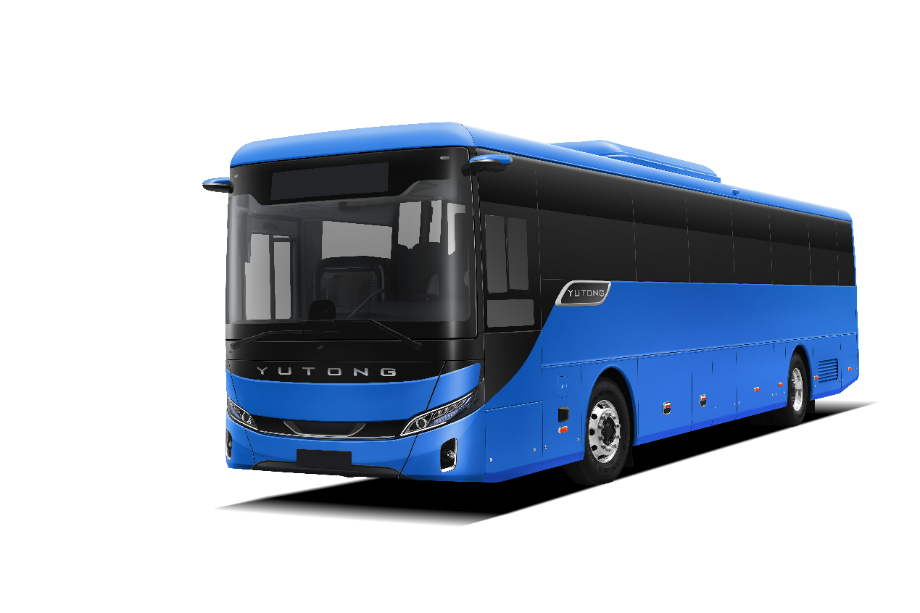

**1. Overall Introduction**

The Yutong IC series, built on the world-leading YEA electric vehicle specific platform, employs cutting-edge NEV technologies to meet premium mobility needs across 12-15 meter vehicles. Combining extended range, high capacity, and exceptional eco-performance, IC12E made its debut at the 2025 UITP Summit Hamburg in Germany, earning widespread acclaim.

Yutong IC12E measures 12.66 meters in length, 2.55 meters in width, and 3.5 meters in height.

It can accommodate up to 61 seats and features a luggage compartment with a maximum capacity of 4.5 m³.

Its 465.99kWh battery adapts to various operational needs. Thanks to lightweight design and energy-saving technology, the vehicle achieves outstanding energy efficiency, delivering a maximum range of 675km under SORT2 conditions. Combining technology with aesthetics, this product is designed for premium intercity public transportation.

**2. Core Selling Points**

1. ​​Exceptional range​​: Equipped with a 465 kWh battery, it delivers a maximum range of 675 km under SORT2 working conditions.

2. Super eco-friendliness​​: Every 100 12-meter electric buses can save 2 million liters of fuel annually, reducing PM emissions by 630 kg, NOx emissions by 31 tons, and CO2 emissions by over 5,260 tons. This is equivalent to planting 40,000 trees across 20 football fields.

3. High capacity​​: With a maximum load capacity of 19,500 kg, it can accommodate up to 59 passengers and offers a luggage compartment with a maximum capacity of 4.5 m³.

**3. Secondary Selling Points**

1. Super safety: It is equipped with YESS+YEA safety control strategy, with nitrogen protection, battery liquid thermal system and 24H battery system monitoring device as standard configuration to help ensure safe and worry-free operation.

2. Strong durability​​: Featuring the internationally leading electrocoating technology and enhanced anti-corrosion processes, along with high specific energy LFP batteries, the vehicle and battery both achieve a service life of 15 years/1.5 million kilometers.

3. Superior Comfort: The driver seat equipped with heated and shock-absorbing functions and passenger seats with adjustable armrests together deliver a more humanized experience for both drivers and passengers.

Yutong IC series is safe, reliable, comfortable and intelligent, bringing better choices for travel.

|  |  |
| --- | --- |
| **IC12E** | **The Standard of Battery Electric Intercity Bus** |
| **Parameters** | |
| L*W*H(mm) | 12660*2550*3500 |
| Minimum turning diameter(m) | 19 |
| Approach /departure angle | 7.5°/8° |
| **Passenger area** | |
| Wheelchair area | 1 |
| Maximum number of seats | 61 |
| Maximum volume of baggage(m3) | 4.5 |
| **Battery and charging** | |
| Battery capacity(kWh) | 399.92/465.99 |
| **Powertrain** | |
| Rated power of motor (kW) | 215/250/430 |
| Tire | 295/80R22,5 |
| Axle | Front axle: ZF independent axle, Drive axle: ZF |
| Suspension | Airbag suspension, ECAS, with kneeling |
| **Highlights** | |
| **Enhanced range:** Equipped with a 465kWh battery, it delivers a maximum range of 675 km (SORT2 conditions).  **Super eco-friendly:** Every 100 battery electric buses (12m) save 2 million liters of fuel annually, cutting emissions by 630 kg PM, 31 tons NOx, and over 5,260 tons CO₂-equivalent to planting 40,000 trees across 20 soccer fields.  **Superior capacity:** 19,500 kg maximum load capacity; seats up to 59 passengers with 4.5 m³ maximum luggage space. | |

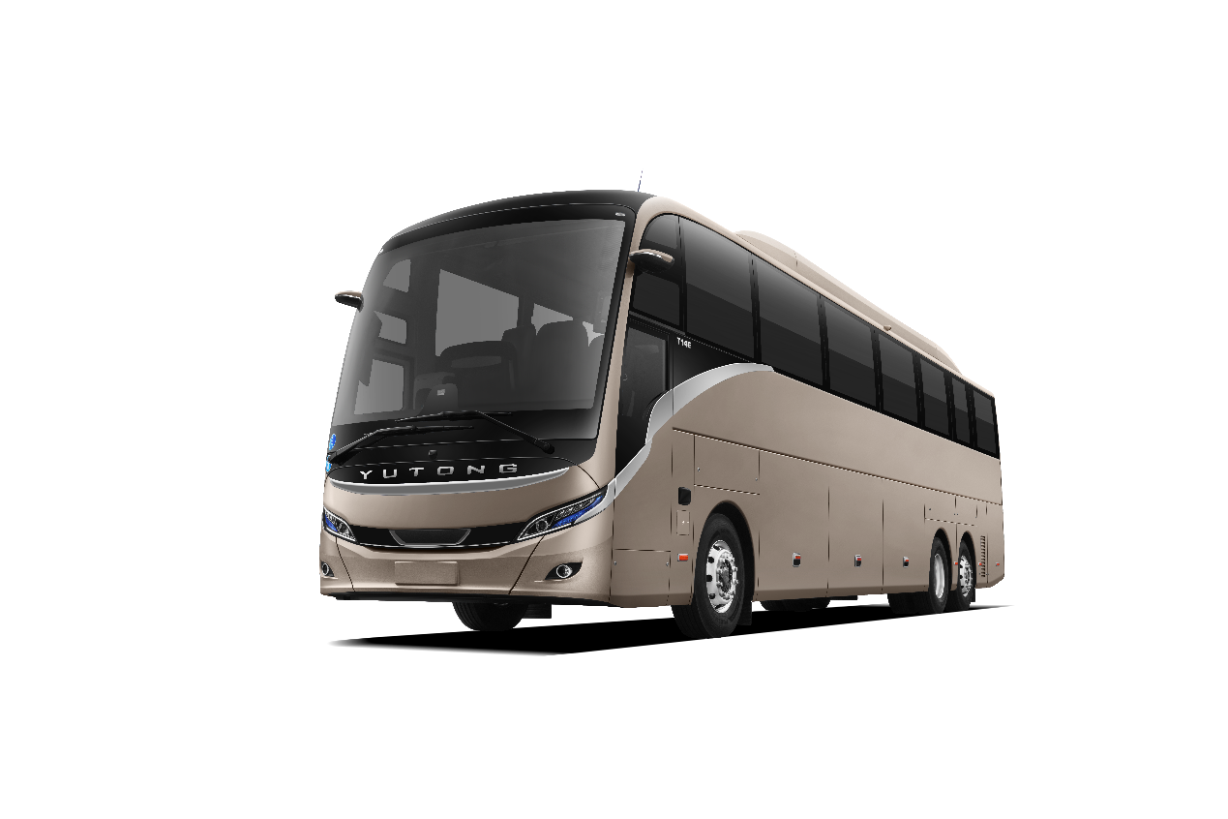**II. T14E (14m Premium Battery Electric Tourist Bus)**

**1. Overall Introduction**

The Yutong T Series is designed for the premium tourist coach market, available in both electric and diesel variants, with models spanning 12 to 15 meters. Since its European launch in 2023, the T Series has sold over 400 units across Norway, the UK, Italy, Denmark, and other countries. Renowned for its reliability, durability, and eco-friendly performance, the T Series has earned widespread customer acclaim. It also won the Design and Ecology Label at the Busworld Europe 2023.

Yutong T14E measures 13.97 meters in length, 2.55 meters in width, and 3.9 meters in height. It can accommodate up to 59 seats and features a luggage compartment with a maximum capacity of 8 m³.

Yutong has launched a large battery electric tourist coach, equipped with an ultra-high battery capacity (621.33/704.17 kWh). Featuring lightweight design and energy-saving technology, these vehicles deliver outstanding energy efficiency with a maximum range of 850km (704kWh under SORT3 conditions), meeting diverse operational needs.

**2. Core Selling Points**

1. Extended Range: Features a high-efficiency permanent magnet synchronous motor and the latest BMS battery management system, delivering a maximum range of 850 km (704kWh, SORT3 conditions). With the industry's first megawatt liquid-cooled dual-plug charging system, the 704kWh battery charges fully in just 1.2 hours. Its 20% max gradeability (15km/h, 20 seconds) ensures performance across diverse road conditions.

2. Enhanced safety: Adopting a through-type pillar body structure and 700MPa high-strength steel, it meets related requirements of EU R66, R29, R93 and other regulations.

3. Super-efficient: Featuring a next-generation intelligent electric chassis with a heavy-duty silicon carbide integrated controller, the industry's first unified vehicle thermal management system, and high-energy-density LFP batteries (designed for up to 1.5 million km/15 years of service), delivering 15% lower energy consumption and 50% longer lifespan.

**3. Secondary Selling Points**

1. Beautiful appearance: Its styling has won the 2023 Busworld Design Label. It is more distinctive with the smiling front face design, the slender vehicle lines.

2. Driving control: The scientifically designed cockpit puts all controls within easy reach for effortless operation. Featuring an intelligent cabin system and next-generation high-comfort coach seats with massage and heating functions, plus CDC adaptive damping technology for an exceptionally smooth ride. USB and Type-C charging ports ensure a comfortable, worry-free journey.

3. Operation intelligence​​: Enhancing fleet efficiency through real-time monitoring, OTA updates, remote control, smart after-sales services, fault diagnostics, and maintenance guidance.

The T-series vehicles have entered markets in Denmark, Norway, Italy, Portugal, and other countries. With their low energy consumption, broad environmental adaptability, and high customer satisfaction, the T-series has recently secured bulk orders from multiple nations. Safe, reliable, comfortable, and intelligent, Yutong's premium T-series coaches offer travelers a superior choice.

|  |  |
| --- | --- |
| **T14E** | **14m Premium Battery Electric Tourist Bus** |
| **Parameters** | |
| L*W*H(mm) | 13970*2550*3900 |
| Wheelbase(mm) | 7100+1515 |
| Minimum turning diameter(m) | ≤21 |
| Approach /departure angle | 9°/9° |
| Luggage compartment volume (m³) | 8 |
| Maximum number of seats | 59 |
| **Battery and charging** | |
| Battery capacity (kWh) | 621.33, liquid cooling  optional 704.17, liquid cooling |
| Charging system | CCS2, DC dual charging socket |
| **Powertrain** | |
| Rated power of motor(kW) | 250/430 |
| Tire | 295/80R22.5 |
| Axle | Three-axle disc type (Front ZF, Rear ZF, Third axle ZF) |
| Suspension | Air spring suspension, ECAS, with kneeling |
| **Highlights** | |
| **Long range:** Equipped with 621/704 kWh battery, the maximum range reaches 850 km (704 kWh, SORT3).  **High safety:** The body uses a through-type pillar structure and 700 MPa high-strength steel, meeting EU regulatory requirements such as R66/R29/R93.  **More economical:** Adopting new-generation intelligent electric chassis, heavy-duty SiC multi-in-one controller, industry-first integrated thermal management system, and high specific-energy LFP batteries (maximum service life: 15 years/1.5 million km). | |

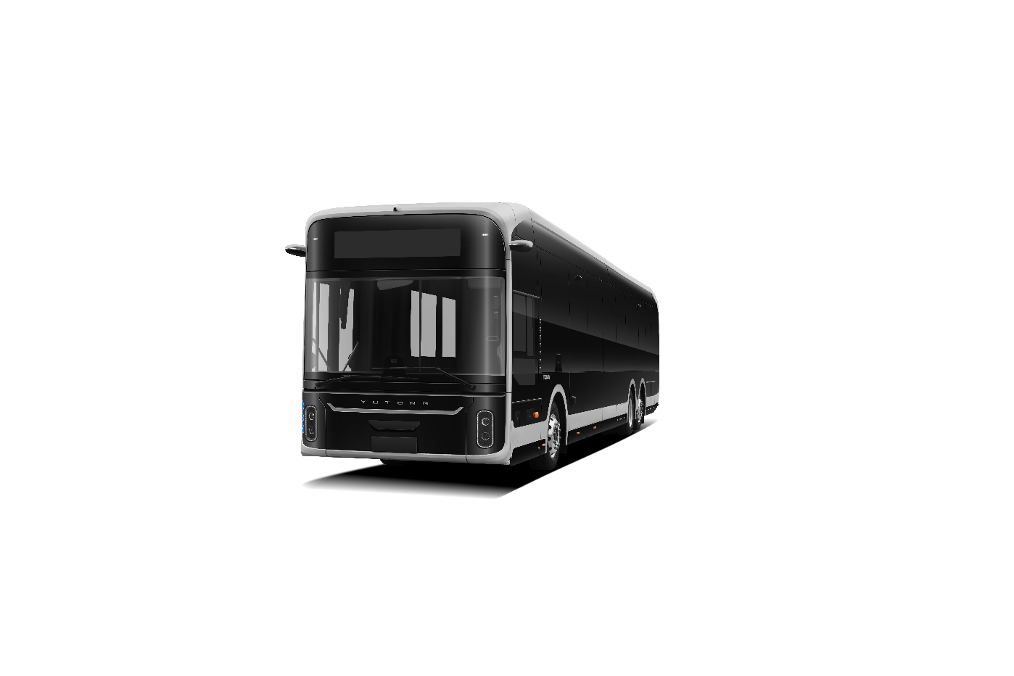**III. U15 (15m Premium City Bus Benchmark)**

**1. Overall Introduction**

Since its launch in 2022, Yutong’s U-series buses have gained widespread recognition from customers, becoming today’s best-selling and most popular electric buses. Available in 10, 12, 13, 15, and 18-meter variants with low-entry and low-floor designs, including both single and double-decker models, these buses now operate in over 14 countries, serving diverse public transit needs from high-capacity trunk lines to low-passenger-flow branch lines.

Yutong U15 measures 14.95 meters in length, 2.55 meters in width, and 3.39 meters in height.

With a maximum capacity of 57 seats or 90 passengers and a 662.75kWh battery pack, this model adapts to various operational needs. Featuring lightweight design and energy-saving technology, it delivers exceptional power efficiency with a maximum range of 850km under SORT2 conditions. This product has Yutong’s everlasting characteristics: safety, reliability, long range, and comfort. Based on the operation experience of Yutong’s new energy buses in the European market for years, U15 enhances passenger comfort through improved user-friendly facilities and advanced new-energy-related and IOV technologies.

**2. Core Selling Points**

1. Safer: The protection grade of battery, motor and electric control can reach IP68 + IP6K9K, equipped with Yutong YESS battery safety protection system, ensuring safety in an all-around way.

2. More durable​​: Featuring the internationally leading electrocoating technology and enhanced anti-corrosion processes, along with high specific energy LFP batteries, the vehicle and battery both achieve a service life of 15 years/1.5 million kilometers.

3. More intelligent: The powerful intelligent monitoring platform, paired with the LINK+ fleet management system, collects data related to vehicle operation, road conditions, etc. in an all-round way, and gives early warning according to the feedback data, realizing smart travel under control.

**3. Secondary Selling Points**

Yutong's 15-meter battery electric bus meets urban passenger transport needs with superior safety and highly economical operation and maintenance advantages.

1. Super safety: It is equipped with YESS + YEA safety control strategy, with nitrogen protection system, battery liquid-heating system and 24H battery system monitoring device as standard configuration to help ensure safe and worry-free operation.

2. Ultra-efficient operation: Industry-first smart energy-saving technology intelligently adjusts energy recovery, doubling kinetic energy utilization for a maximum range of 850km (SORT2 conditions).

3. Super Comfort: Features a shock-absorbing, heated driver's seat with adjustable armrests, delivering a more ergonomic experience for both drivers and passengers.

Yutong U series is safe, reliable, comfortable and intelligent, bringing better choices for travel.

|  |  |
| --- | --- |
| **U15** | **15m Premium City Bus Benchmark** |
| **Parameters** | |
| L*W*H(mm) | 14950×2550×3390 |
| Minimum turning diameter(m) | ≤22 |
| Approach /departure angle | 7°/7° |
| **Passenger area** | |
| Floor type | Low entrance |
| Wheelchair area | 1 |
| Passenger door | 2-2-0 |
| Maximum number of seats | 57 |
| **Battery and charging** | |
| Battery capacity (kWh) | 662.75, liquid cooling |
| Charging system | Supports up to 1400A liquid-cooling dual-plug charging |
| **Powertrain** | |
| Rated power of motor (kW) | 250 |
| Tire | 275/70R22.5 |
| Axle | Three-axle disc type (Front ZF, Rear ZF, Third axle ZF) |
| Suspension | Airbag suspension, ECAS, with kneeling |
| **Highlights** | |
| **Super intelligence:** Equipped with LINK+ fleet management system, operational data is visualized and vehicle management is smarter. **Super appearance:** Winner of 2019 Busworld Design Label. **Super safety:** Protection grade of battery, motor and electric control reaches IP68 + IP6K9K, equipped with Yutong YESS battery safety protection system, ensuring safety in an all-around way. | |

**IV. U11DD (Battery Electric Double-Decker with Ultra-Long Driving Range)**

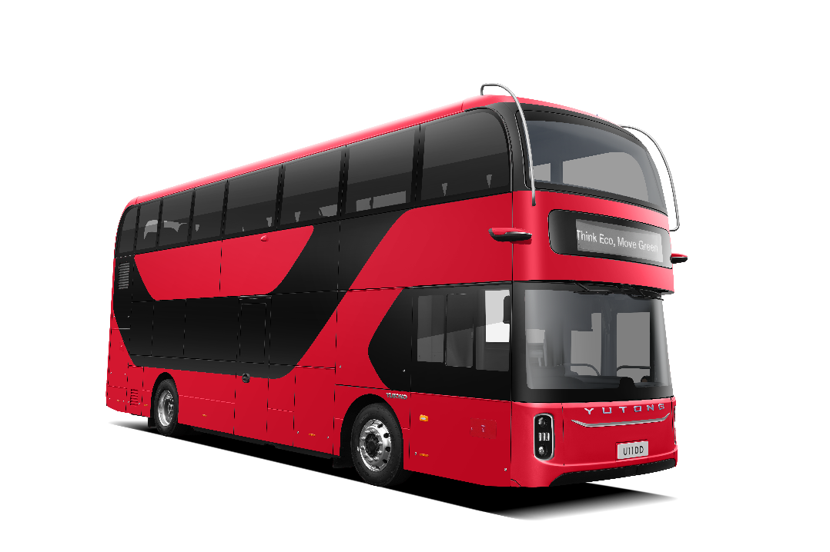

**1. Overall Introduction**

Yutong U11DD measures 10.88 meters in length, 2.55 meters in width, and 4.35 meters in height.

Its upper deck has 42 seats while the lower deck accommodates 20, with a total capacity of 87 passengers.

The standard battery capacity is 467.38kWh, with an optional 556.41kWh configuration to accommodate different operational needs. Featuring lightweight aluminum body design and energy-saving technologies, the vehicle delivers outstanding power efficiency. The 467kWh battery achieves over 625km range under ULEB conditions. This product combines high safety, low energy consumption, and large passenger capacity, making it ideal for European urban environments with narrow roads and frequent stops at traffic lights and speed bumps.

**2. Core Selling Points**

1. Large capacity: up to 70 seats and a maximum capacity of 87 passengers, meeting peak-hour demand.

2. Enhanced safety: The protection grade can reach IP68 + IP6K9K, equipped with Yutong YESS battery safety protection system, ensuring battery safety and protecting drivers and passengers.

3. Long driving range: Equipped with a next-generation 556kWh long-life battery, achieving 750 km under ULEB conditions.

**3. Secondary Selling Points**

Yutong’s 11m double-decker meet the needs of busy trunk road operation scenarios and have three major characteristics: beautiful appearance, trustworthy reliability and easy maintenance.

1. Beautiful appearance: Inheriting the U-series design styling with its technological curved surfaces, the runway-inspired LED headlights and triple-ring LED taillights create a premium, intelligent urban signature.

2. Trustworthy reliability: The all-aluminum vehicle body employs Y.E.S. electrocoating technology for corrosion resistance, with the vehicle’s main structure designed for a service life of 20 years or 2 million kilometers. The vehicle is also equipped with EBS, ESP, HSA and other auxiliary operating systems to ensure transportation safety.

3. Easy maintenance: Modular design for bumpers, body panels, headlights and other components enables easier operation and more efficient maintenance. Equipped with Link+ fleet management system for visualized operational data and smarter vehicle management.

|  |  |
| --- | --- |
| **U11DD** | **Battery Electric Double-Decker with Ultra-Long Driving Range** |
| **Parameters** | |
| L*W*H(mm) | 10880*2550*4350 |
| Wheelbase(mm) | 5550 |
| Minimum turning diameter(m) | ≤18 |
| Approach /departure angle | 7.5°/7.5° |
| **Passenger area** | |
| Floor type | Low floor |
| Wheelchair area | 1 |
| Maximum number of seats | 70 |
| Maximum passenger capacity | 87 |
| **Battery and charging** | |
| Battery capacity (kWh) | 467.38, liquid cooling |
| Charging system | Supports up to 1400A liquid-cooling dual-plug charging |
| **Powertrain** | |
| Power of motor (kW) | 220 |
| Tire | 275/70R22.5 |
| Axle | Front axle ZF RL82EC, Drive axle ZF |
| Suspension | Airbag suspension, with lifting system (with kneeling) |
| **Highlights** | |
| **Larger capacity:** 42 seats on the upper deck, 20 seats on the lower deck, with a maximum passenger capacity of 87 people **Higher safety:** Protection grade reaches IP68 + IP6K9K, equipped with Yutong YESS battery safety protection system, ensuring safety in an all-around way. **Extended driving range:** Lightweight technology and efficient motor ensure lower energy consumption and a driving range up to 750 km. | |